Lesson plans 4, 5 and 6: Password strength program

About the lesson
In these lessons, students complete the second of the two coding tasks that form Project 1: password strength program. They will need to utilise the iterative approach to program development, debugging and testing versions of the program as they develop it.
Learning objectives
During these lessons, students will demonstrate:
- their ability to write a program in Python
- their understanding of testing
- the importance of versioning.
National Curriculum
The following subject content from the KS3 National Curriculum is included in this lesson:
- Use two or more programming languages, at least one of which is textual, to solve variety of computational problems.
Links
The basic programming constructs covered in this module follow on from work the students may have covered in Programming in Python: sequence, Programming in Python: selection and Programming in Python: iteration.
The iterative approach to problem solving has a wide range of applications in many areas, especially those involving computer programming. Completing this module will provide a sound basis for a KS4 course that includes computer programming.
Key terminology
iterative approach to project development, bug, debug, test, normal data, abnormal data, boundary data, version, if statement, else statement, if else statement, string, Boolean variable, logical operators, and
Teaching and learning activities
Remind students of the objectives for the lessons (Slide 2 of Lesson presentation).
Starter
Explain to students that they will be completing the second of the two coding tasks that form this project: writing a password strength program.
If appropriate, remind students about the iterative approach to project development, how to debug and test a program and the importance of saving each version of a program while it is in development (Slides 3–8 and page 198-199).
Ask students to complete Project 1.2: Password strength program (Worksheet 1.2, page 201, slide 12 and Key points for students).
- Students should code their password strength program over three lessons, working at their own pace. Unlike the arithmetic quiz, this part of the project is not divided into sections, but students should be encouraged to complete the program in sections.
- Worksheet 1.2 contains a brief summary of the key coding concepts students will need to complete this project, and students can record their testing in the test tables in the worksheet.
- Indicative answers, typical of what might be seen as the program develops, are provided below.
Design
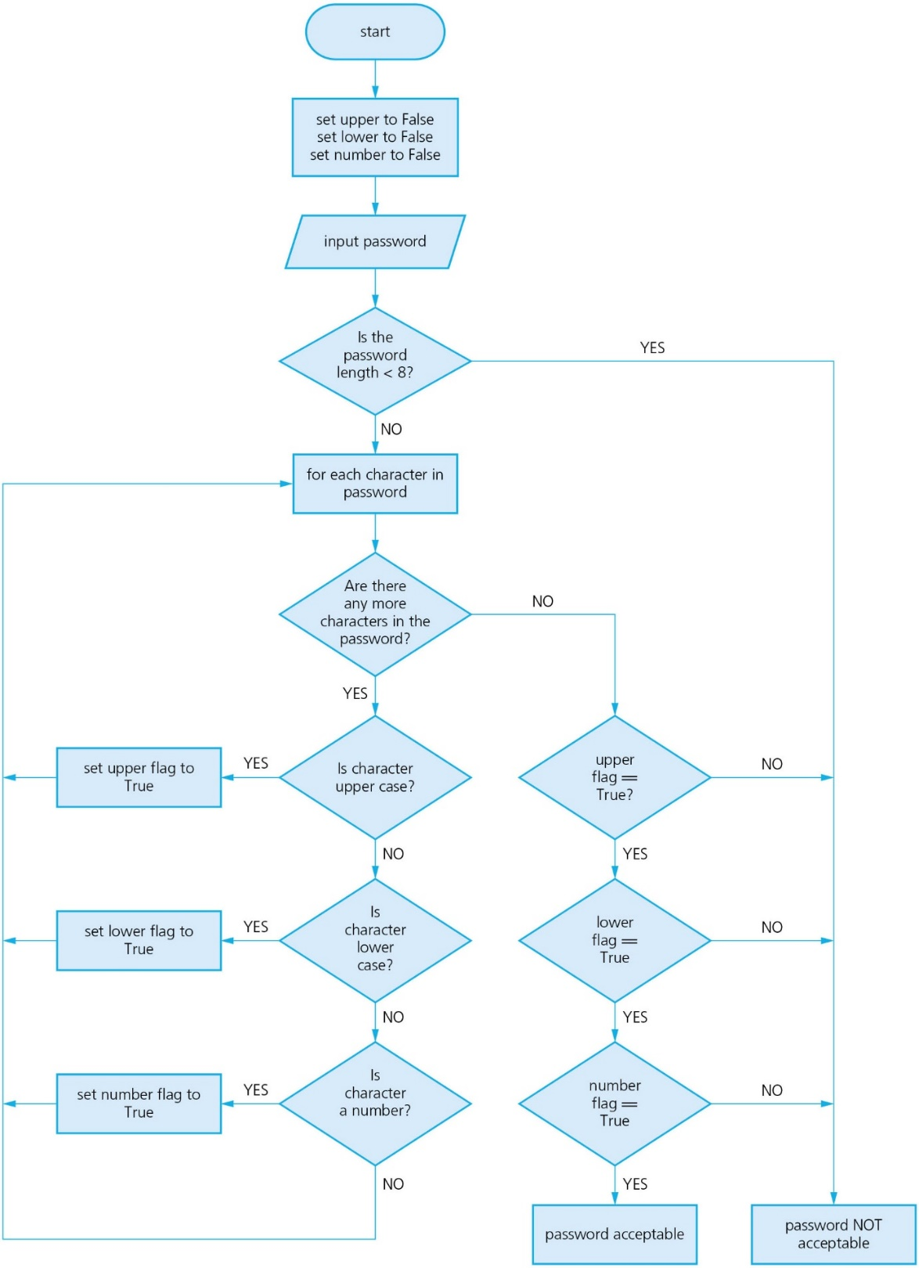
Indicative answers
Version 1
Version 1 could check for password length and inclusion of upper case. There could be additional versions showing the addition of each requirement in turn.
upper = False
password = input('Enter your password: ')
if len(password) < 8:
print('Password NOT acceptable')
else:
for character in password:
if character >= 'A' and character <= 'Z':
upper = True
if upper:
print('Password acceptable.')
else:
print('Password NOT acceptable.')
The Boolean variable used as a flag need to be initialised to False. False must have an initial capital letter.
To find out if a character is upper case, the program checks to see if it lies between 'A' and 'Z'. Students could also use ASCII values, in which case, the seventh line of code would be: if ord(letter) >= 65 and ord(letter) <= 90:
but this is a little untidy and overcomplicated.
Make sure the program contains two complete conditions joined by
and. letter >= 'A' and <= 'Z'
is not correct because the second condition is not complete.
Indicative answers
Version 2
Version 2 checks for all four requirements.
upper = False
lower = False
number = False
password = input('Enter your password: ')
if len(password) < 8:
print('Password NOT acceptable')
else:
for character in password:
if character >= 'A' and character <= 'Z':
upper = True
if character >= 'a' and character <= 'z':
lower = True
if character >= '0' and character <= '9':
number = True
if upper and lower and number:
print('Password acceptable.')
else:
print('Password NOT acceptable.')
The final if statements checks to see if the flags are all True. Expressing this as follows is still acceptable: upper == True and lower == True and number == True
End-of-KS3 assessment
Use the 'Project 1' tab of Projects: Assessment (Excel) or Projects: Assessment (Google Sheets) to mark students' programs.

Plenary
As with the first part of the project, give students five minutes at the end of each lesson to ask their classmates for help on anything they are struggling with. This could be done as a class, in small groups or in pairs.
Homework
If appropriate, ask students to continue working on their project.
Stretch and support activities
The activities in this module are intended to stretch students so most will require all the time available and some may only be able to complete parts of the activity.
Some students may find these activities straightforward and complete the tasks very quickly. These students should be encouraged to experiment and design, write and test their own additional features.
Any students with some experience of another programming language can complete the same tasks in that language. A wide experience of programming languages is to be encouraged where there is an interest.
Remember the PRIMM approach: Predict, Run, Investigate, Modify, Make approach to make these activities more effective.
Some students may find it challenging to complete all the elements of the activities and should be encouraged to concentrate on getting the early parts of the activity as complete as possible. Some students may benefit from concentrating on the first programming activity for a little longer rather than move on to this one. It may be necessary to provide some additional support for students who are finding the activity challenging by using the indicative solutions with parts edited out for them to complete.
W3 schools provides a useful guide to Python programming which can be found at https://www.w3schools.com/python/default.asp

